- Making a Line using General DDA
// Shafin Ahmed 232-15-184 65-M1

// Styraight line
#include <GL/gl.h>
#include <GL/glut.h>
#include <stdio.h>
#include <math.h>

// Global Variables
float x1, y_1, x2, y2;

void display()
{
glClear(GL_COLOR_BUFFER_BIT);
glColor3f(0.0, 1.0, 0.0);
glBegin(GL_POINTS);

// ==========================
// TODO:
// Implement DDA Algorithm
// Plot point using: glVertex2f(x, y)
// ==========================

float dx = x2 - x1;
float dy = y2 - y_1;
float steps;

// Take max
if (fabs(dx) > fabs(dy))
{
steps = fabs(dx);
}
else
{
steps = fabs(dy);
}

// Increment factors of x and y axis
float xIncrement = dx / steps;
float yIncrement = dy / steps;

// Start positions
float x = x1;
float y = y_1;

// Plot point using:
glVertex2f(x, y);

// Loop
for (int i = 0; i < steps; i++)
{
x += xIncrement;
y += yIncrement;

glVertex2f(x, y);
}

glEnd();
glFlush();
}

void init()
{

glClearColor(0.0, 0.0, 0.0, 0.0);

glMatrixMode(GL_PROJECTION);
glLoadIdentity();
glOrtho(0, 100, 0, 100, -1, 1);
}

int main(int argc, char** argv)
{
printf("Enter First Point (x1 y_1): ");
scanf("%f %f", &x1, &y_1);

printf("Enter Second Point (x2 y2): ");
scanf("%f %f", &x2, &y2);

glutInit(&argc, argv);
glutInitDisplayMode(GLUT_SINGLE | GLUT_RGB);
glutInitWindowSize(600, 600);
glutInitWindowPosition(100, 100);
glutCreateWindow("DDA Line Drawing by Shafin Ahmed 232-15-184 65-M1");

init();

glutDisplayFunc(display);

glutMainLoop();

return 0;
}
Output:
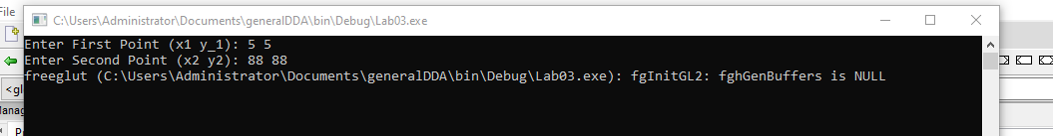
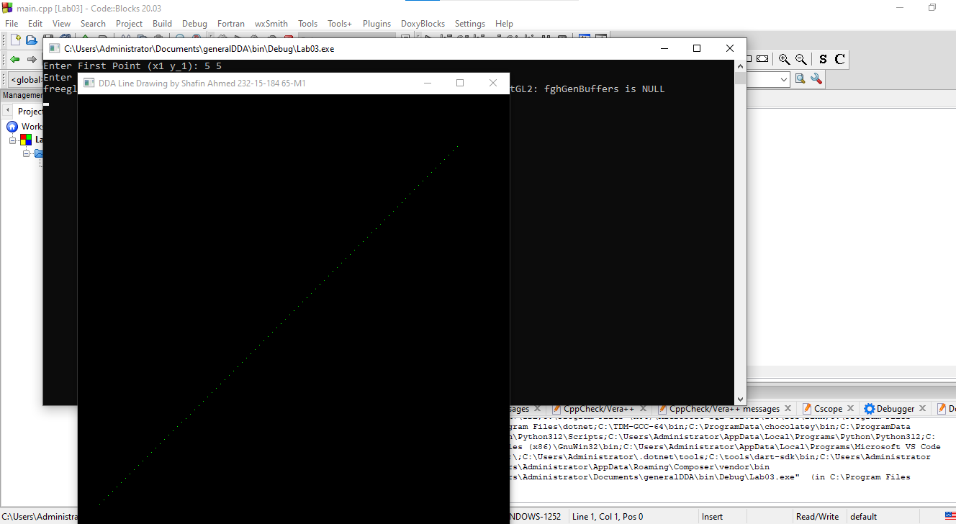
- Home Using DDA
- // Shafin Ahmed 232-15-184 65-M1

- #include <GL/gl.h>
- #include <GL/glut.h>
- #include <stdio.h>
- #include <math.h>

- void abc(float x1, float y_1, float x2, float y2)
- {
- float dx = x2 - x1;
- float dy = y2 - y_1;
- float steps;

- //max
- if (fabs(dx) > fabs(dy))
- {
- steps = fabs(dx);
- }
- else
- {
- steps = fabs(dy);
- }

- //inc
- float xIncrement = dx / steps;
- float yIncrement = dy / steps;

- // Start pos
- float x = x1;
- float y = y_1;

- //start point
- glVertex2f(x, y);

- // Loop
- for (int i = 0; i < steps; i++)
- {
- x += xIncrement;
- y += yIncrement;
- glVertex2f(x, y);
- }
- }

- void display()
- {
- glClear(GL_COLOR_BUFFER_BIT);
- glColor3f(0.0, 1.0, 0.0);

- glBegin(GL_POINTS);

- // ghor
- abc(15, 15, 75, 15); // niche
- abc(75, 15, 75, 50); // Dan
- abc(15, 50, 75, 50); // upor
- abc(15, 15, 15, 50); // bam

- //chal
- abc(15, 50, 45, 85); // bam
- abc(75, 50, 45, 85); // dan

- glEnd();
- glFlush();
- }

- void init()
- {
- glClearColor(0.0, 0.0, 0.0, 0.0);
- glLoadIdentity();
- glOrtho(0, 100, 0, 100, -1, 1);
- }

- int main(int argc, char** argv)
- {
- glutInit(&argc, argv);
- glutInitDisplayMode(GLUT_SINGLE | GLUT_RGB);
- glutInitWindowSize(600, 600);
- glutInitWindowPosition(100, 100);
- glutCreateWindow("DDA Home Drawing by Shafin Ahmed (232-15-184 65-M1");

- init();
- glutDisplayFunc(display);
- glutMainLoop();

- return 0;
- }

Output:
